**Structure of M-Commerce**

Mobile Commerce refers to wireless electronic commerce used for conducting commerce or business through a handy device like cellular phone or Personal Digital Assistant (PDAs).

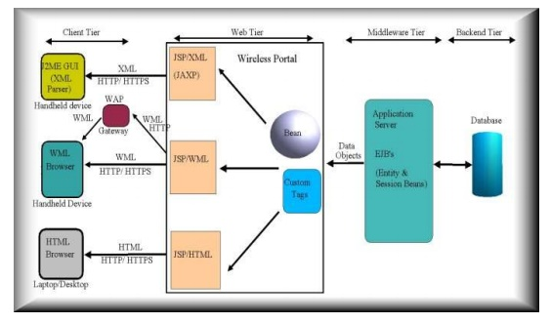

**Mobile commerce applications**: A content provider implements an application by providing two sets of programs: client-side programs, such as a user interface on a microbrowser , and server-side programs, such as database accesses and updating.

**Mobile stations**: Mobile stations present user interfaces to the end users, who specify their requests on the interfaces. The mobile stations then relay user requests to the other components and display the processing results later using the interfaces.

**Mobile middleware**: The major purpose of mobile middleware is to seamlessly and transparently map Internet contents to mobile stations that support a wide variety of operating systems, markup languages, microbrowsers , and protocols. Most mobile middleware also encrypts the communication in order to provide some level of security for transactions.

**Wireless networks**: Mobile commerce is possible mainly because of the availability of wireless networks. User requests are delivered to either the closest wireless access point (in a wireless local area network environment) or a base station (in a cellular network environment).

**Wired networks**: This component is optional for a mobile commerce system. However, most computers (servers) usually reside on wired networks, such as the Internet, so user requests are routed to these servers using transport and/or security mechanisms provided by wired networks.

**Host computers**: This component is similar to the one used in electronic commerce, which includes three kinds of software. User requests are generally acted upon in this component.

**Mobile Commerce Applications**

|  |  |  |
| --- | --- | --- |
| Mobile Category | Major Applications | Clients |
| Commerce | Mobile transactions and  payments | Businesses |
| Education | Mobile classrooms and  labs | Schools and  training centers |
| Enterprise  resource planning | Resource management | All companies |
| Entertainment | Music/video/game  downloads | Entertainment  industry |
| Health care | Patient record  accessing | Hospitals and  nursing homes |
| Inventory tracking and  dispatching | Product tracking and dispatching | Delivery services and  transportation |
| Traffic | A global positioning, directions, and traffic  advisories | Transportation and auto  industries |
| Travel and  ticketing | Travel management | Travel industry  and ticket sales |